DCC-GARCH correlation: EURUSD and GBPUSD
Method 09 / GARCH(1,1) + Engle DCC / Alpari D1 full available history

Study setup
Logical pair: EURUSD , GBPUSD
Broker symbols: EURUSD_i , GBPUSD_i
Snapshot: 2026-11-03_majors_alpari_D1
Timeframe: D1
Matched return window: 1999-01-05 to 2026-11-02 (UTC bar dates)
Matched return count n: 7202
Dropped unfinished last bar dated 2026-11-03 UTC after a tick-volume check against the prior complete day.
EURUSD GARCH(1,1): mu=0.000010, omega=0.001152, alpha=0.036679, beta=0.960040
GBPUSD GARCH(1,1): mu=0.000018, omega=0.004029, alpha=0.055460, beta=0.932146
DCC: a=0.023581, b=0.974449, a+b=0.998030
Burn-in ignored in path summaries and chart: first 60 updates
Complete matched rows (Excel): EURUSD-GBPUSD_DCC_D1.xlsx
Complete matched rows (HTML table): EURUSD-GBPUSD_DCC_D1_data.html

Method carried forward
DCC-GARCH first fits a constant-mean GARCH(1,1) on each matched daily log return of close, ln(close_t / close_t-1), then updates Engle (2002) dynamic conditional correlation on the standardised shocks z = residual / conditional sigma. Quotes are not inverted. Correlation targeting sets Q_bar to the sample correlation of z; a and b are estimated by maximising the bivariate Gaussian DCC likelihood with a >= 0, b >= 0, and a + b < 1. Path summaries ignore the first 60 updates. The headline is rho on the last day. Same-sample Pearson r on log returns is a side check only. A high |rho| does not prove cause, lead-lag, or a trading signal.

Results
Latest DCC rho: 0.837699
Post-burn-in path (n=7142): mean=0.655501, median=0.667818, min=0.161142, max=0.879268, std=0.124782
Share of post-burn-in days with |rho| >= 0.4: 95.97%; |rho| >= 0.7: 40.80%
Same-sample Pearson r: 0.641738
Latest rho minus r: 0.195961

Conclusion
Over 7202 matched daily log-return rows for EURUSD and GBPUSD (broker quote directions unchanged), latest DCC rho is 0.8377 (positive, strong conditional linear link in this sample) with fitted a=0.0236, b=0.9744 (a+b=0.9980). After a 60-day burn-in, path mean is 0.6555 and std is 0.1248. Same-sample Pearson r is 0.6417 (latest rho minus r = 0.1960). This does not establish cause, lead-lag, or a lasting trading rule.

Charts
Daily closes

Daily log returns
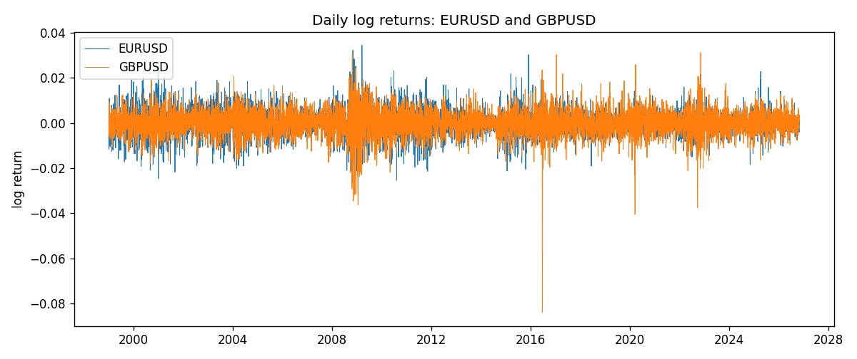
DCC rho path with Pearson r reference
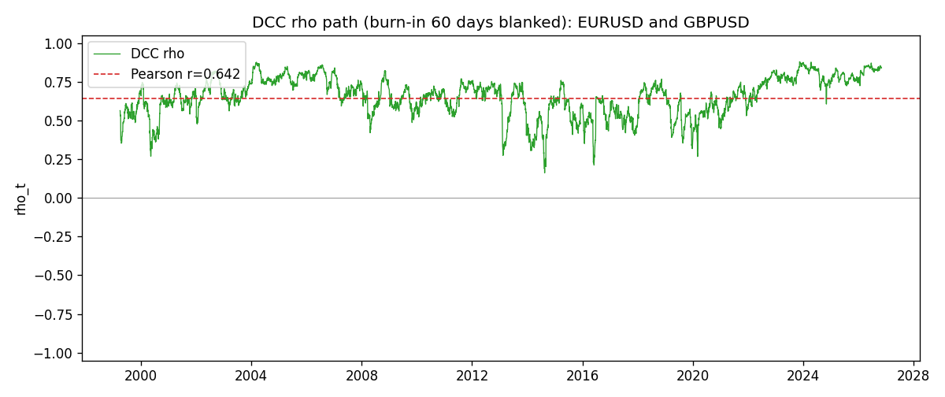

Data report
Every matched row that entered the DCC recursion is stored in the sibling Excel workbook named EURUSD-GBPUSD_DCC_D1.xlsx. Embedding all rows as a Word table is impractical at this length; the Word file holds the column list, column summaries, and the first and last 15 matched rows.
Columns: time, EURUSD_open, GBPUSD_open, EURUSD_high, GBPUSD_high, EURUSD_low, GBPUSD_low, EURUSD_close, GBPUSD_close, EURUSD_tick_volume, GBPUSD_tick_volume, EURUSD_spread, GBPUSD_spread, EURUSD_real_volume, GBPUSD_real_volume, EURUSD_log_return, GBPUSD_log_return, EURUSD_sigma, GBPUSD_sigma, EURUSD_z, GBPUSD_z, q11, q22, q12, rho_t
Column summaries (matched calculation rows)
column | count | mean | std | min | 25% | 50% | 75% | max
EURUSD_open | 7202 | 1.1812936 | 0.15087968 | 0.8272 | 1.086065 | 1.166145 | 1.293925 | 1.5995
GBPUSD_open | 7202 | 1.5160822 | 0.2182507 | 1.06854 | 1.325005 | 1.51141 | 1.63166 | 2.1066
EURUSD_high | 7202 | 1.1864255 | 0.15147858 | 0.8326 | 1.0901775 | 1.17127 | 1.2992275 | 1.6038
GBPUSD_high | 7202 | 1.5223773 | 0.21881719 | 1.08366 | 1.329795 | 1.51815 | 1.63839 | 2.1161
EURUSD_low | 7202 | 1.1762813 | 0.15020267 | 0.8227 | 1.0819975 | 1.162535 | 1.288315 | 1.5865
GBPUSD_low | 7202 | 1.5097565 | 0.21747799 | 1.03518 | 1.3195075 | 1.503295 | 1.6243825 | 2.0983
EURUSD_close | 7202 | 1.1813323 | 0.15085599 | 0.8267 | 1.0860025 | 1.166105 | 1.2939475 | 1.5997
GBPUSD_close | 7202 | 1.5161468 | 0.21820921 | 1.06879 | 1.325125 | 1.511325 | 1.632095 | 2.1065
EURUSD_tick_volume | 7202 | 102990.53 | 173401.83 | 218 | 9388.25 | 52708 | 99433.75 | 1471626
GBPUSD_tick_volume | 7202 | 94813.509 | 153540.37 | 62 | 9988.5 | 52886.5 | 91789.25 | 1273370
EURUSD_spread | 7202 | 19.400444 | 16.577153 | 0 | 8 | 12 | 30 | 50
GBPUSD_spread | 7202 | 26.974313 | 19.194125 | 0 | 11 | 20 | 50 | 50
EURUSD_real_volume | 7202 | 4.0233049e+10 | 1.6674277e+11 | 0 | 0 | 0 | 0 | 3.6149665e+12
GBPUSD_real_volume | 7202 | 3.5555961e+09 | 8.4432361e+10 | 0 | 0 | 0 | 0 | 2.4038164e+12
EURUSD_log_return | 7202 | -7.71e-06 | 0.00580133 | -0.03123819 | -0.00324586 | 0 | 0.00325471 | 0.03433183
GBPUSD_log_return | 7202 | -2.587e-05 | 0.00564523 | -0.08388241 | -0.00313091 | 3.124e-05 | 0.00317757 | 0.03112653
EURUSD_sigma | 7202 | 0.00556808 | 0.00169675 | 0.00258082 | 0.00432516 | 0.00539106 | 0.0064976 | 0.01458793
GBPUSD_sigma | 7202 | 0.00539671 | 0.00169294 | 0.00300398 | 0.00447848 | 0.00504229 | 0.00577801 | 0.02200621
EURUSD_z | 7202 | -0.00323593 | 1.0000297 | -5.7798919 | -0.62020335 | -0.0016305 | 0.60909431 | 5.2048113
GBPUSD_z | 7202 | -0.00678939 | 1.0000224 | -10.305923 | -0.60017739 | 0.00295214 | 0.6074469 | 4.9458701
q11 | 7202 | 1.0009363 | 0.18089472 | 0.56588192 | 0.87765659 | 0.98604268 | 1.1034405 | 1.9852718
q22 | 7202 | 1.0014148 | 0.21182393 | 0.52786321 | 0.89248027 | 0.98084346 | 1.0725994 | 3.8669555
q12 | 7202 | 0.65524471 | 0.17047132 | 0.100273 | 0.54714699 | 0.65080822 | 0.74856817 | 1.5962746
rho_t | 7202 | 0.65538534 | 0.12433262 | 0.1611421 | 0.58317475 | 0.66739897 | 0.7480584 | 0.87926775
First 15 matched rows (selected columns)
time | EURUSD_log_return | GBPUSD_log_return | EURUSD_sigma | GBPUSD_sigma | EURUSD_z | GBPUSD_z | q11 | q22 | q12 | rho_t
1999-01-05 | -0.0048360507 | -0.0028966287 | 0.0065775723 | 0.0040776923 | -0.73670137 | -0.7146517 | 1 | 1 | 0.65522956 | 0.65522956
1999-01-06 | -0.011547966 | -0.00060452184 | 0.0065201228 | 0.00404638 | -1.7726081 | -0.15372331 | 0.98921704 | 0.9884624 | 0.65219362 | 0.65955448
1999-01-07 | 0.0076280636 | -0.002118709 | 0.0067696266 | 0.0039606247 | 1.1253808 | -0.5393619 | 1.0400066 | 0.96573333 | 0.64324579 | 0.6418452
1999-01-08 | -0.010902799 | -0.0058954193 | 0.0068000396 | 0.0039087243 | -1.6047635 | -1.5127494 | 1.0452683 | 0.94988779 | 0.61378751 | 0.61598197
1999-01-11 | -0.007103287 | -0.0056851331 | 0.006991113 | 0.0040722687 | -1.0174264 | -1.400358 | 1.0812582 | 0.98155039 | 0.656641 | 0.63739257
1999-01-12 | 0.0045103728 | 0.0022657001 | 0.006992385 | 0.004202926 | 0.64365977 | 0.53491284 | 1.0800109 | 1.0046833 | 0.67475135 | 0.64776144
1999-01-13 | 0.010845346 | 0.0091330396 | 0.0069135944 | 0.0041411567 | 1.567302 | 2.2012059 | 1.064155 | 0.98772984 | 0.66692052 | 0.65050785
1999-01-14 | 0 | 0.0019376331 | 0.0070929152 | 0.0045822271 | -0.0013613418 | 0.41903903 | 1.0968602 | 1.07872 | 0.73252453 | 0.67342957
1999-01-15 | -0.010153245 | -0.0017558204 | 0.0069580332 | 0.0044921545 | -1.4605997 | -0.39475968 | 1.0708042 | 1.0572682 | 0.71508504 | 0.67206316
1999-01-18 | 0.0036256946 | 0.0012112405 | 0.0070981033 | 0.0044031225 | 0.50943732 | 0.27111201 | 1.0957207 | 1.0358985 | 0.71170114 | 0.66801947
1999-01-19 | -0.00017235436 | 0.0018745281 | 0.0069974642 | 0.0043074223 | -0.026010886 | 0.43112259 | 1.0758137 | 1.0131334 | 0.69806406 | 0.66864165
1999-01-20 | -0.0031939256 | -0.0049053846 | 0.0068647099 | 0.0042295479 | -0.46667399 | -1.1639271 | 1.0503114 | 0.99359967 | 0.6812541 | 0.6668749
1999-01-21 | 0.0030215416 | 0.0031518998 | 0.0067625979 | 0.0042921079 | 0.44537406 | 0.73027026 | 1.0305804 | 1.0021281 | 0.67794675 | 0.66710323
1999-01-22 | -0.0012075213 | 0.0024781662 | 0.0066598141 | 0.0042567506 | -0.18276444 | 0.57806185 | 1.0108954 | 0.99106824 | 0.66958486 | 0.6689609
1999-01-25 | -0.0030251979 | 0.0012066366 | 0.0065383681 | 0.0041987032 | -0.46416073 | 0.28321496 | 0.98782355 | 0.97559511 | 0.65127569 | 0.66342277
Last 15 matched rows (selected columns)
time | EURUSD_log_return | GBPUSD_log_return | EURUSD_sigma | GBPUSD_sigma | EURUSD_z | GBPUSD_z | q11 | q22 | q12 | rho_t
2026-10-13 | 0.0037402957 | 0.0036434319 | 0.0034541904 | 0.0036706287 | 1.080033 | 0.98782282 | 0.89215803 | 0.73899292 | 0.67750275 | 0.8343918
2026-10-14 | -0.0037582255 | -0.0049164679 | 0.0034756712 | 0.0037001792 | -1.084073 | -1.3334405 | 0.89883913 | 0.74509122 | 0.68664085 | 0.83904244
2026-10-15 | 0.0056053107 | 0.0065976411 | 0.003497634 | 0.0038098992 | 1.59984 | 1.7271166 | 0.90555568 | 0.76995211 | 0.70447481 | 0.84367665
2026-10-16 | 0.0017724895 | 0.0037592051 | 0.0036066895 | 0.0040416128 | 0.48876777 | 0.92579476 | 0.94474334 | 0.8225899 | 0.7529227 | 0.85408636
2026-10-19 | -0.0025394633 | -0.0017500314 | 0.0035661661 | 0.0040503846 | -0.71480663 | -0.43638634 | 0.92820749 | 0.82375315 | 0.74564588 | 0.85273
2026-10-20 | 0.0023881672 | 0.0055923442 | 0.0035444101 | 0.0039835388 | 0.67105986 | 1.39947 | 0.91850951 | 0.80916601 | 0.73524027 | 0.85284212
2026-10-21 | -0.00032046717 | 0.0012476328 | 0.0035190186 | 0.0041131945 | -0.093811114 | 0.29906968 | 0.90762968 | 0.83664498 | 0.73989053 | 0.84906809
2026-10-22 | -0.0015949606 | 0.00022396082 | 0.0034652277 | 0.0040320218 | -0.46306236 | 0.051205017 | 0.88661628 | 0.81934698 | 0.72161468 | 0.84664936
2026-10-23 | -0.001338521 | -0.0021146949 | 0.0034260135 | 0.0039445319 | -0.39351185 | -0.54054474 | 0.8709887 | 0.80044363 | 0.70390827 | 0.84303272
2026-10-26 | -0.0022706559 | -0.0024340661 | 0.003383838 | 0.0038934036 | -0.67388325 | -0.62967199 | 0.85435558 | 0.7888516 | 0.69222937 | 0.84320473
2026-10-27 | -0.004152342 | -0.0023648393 | 0.0033613515 | 0.0038556754 | -1.2381918 | -0.61787889 | 0.84520451 | 0.78001523 | 0.685839 | 0.84467517
2026-10-28 | 0.0022262927 | 0.0015771808 | 0.0034055398 | 0.0038177417 | 0.65089147 | 0.40853463 | 0.8617313 | 0.7710577 | 0.68764663 | 0.84359878
2026-10-29 | 0.0022571351 | 0.0035881935 | 0.0033807743 | 0.0037581866 | 0.66478239 | 0.95011047 | 0.85167352 | 0.75726209 | 0.67763778 | 0.84379691
2026-10-30 | -0.0011458446 | 0.0013450605 | 0.0033575787 | 0.0037783059 | -0.34414697 | 0.35136366 | 0.84230369 | 0.76117018 | 0.6765084 | 0.8448857
2026-11-02 | 0.002120569 | 0.0010971256 | 0.0033146618 | 0.0037158535 | 0.63684117 | 0.29054549 | 0.82554482 | 0.74660275 | 0.65766221 | 0.83769855

